# Lab: Data Types and Variables

Problems for in-class lab for the [Python Fundamentals Course @SoftUni](https://softuni.bg/trainings/2442/python-fundamentals-september-2019). Submit your solutions in the SoftUni judge system at <https://judge.softuni.bg/Contests/1721>

## Concat Names

Read two names and a delimiter. Print the names joined by the delimiter.

### Examples

|  |  |
| --- | --- |
| **Input** | **Output** |
| John  Smith  -> | John->Smith |
| Jan  White  <-> | Jan<->White |
| Linda  Terry  => | Linda=>Terry |

### Hints:

* Read the data:

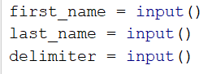

* Print:



## Centuries to Minutes

Write program to enter an integer number of **centuries** and convert it to **years**, **days**, **hours** and **minutes**.

### Examples

|  |  |
| --- | --- |
| **Input** | **Output** |
| 1 | 1 centuries = 100 years = 36524 days = 876576 hours = 52594560 minutes |
| 5 | 5 centuries = 500 years = 182621 days = 4382904 hours = 262974240 minutes |

### Hints

* Assume that a year has 365.2422 days at average ([the Tropical year](https://en.wikipedia.org/wiki/Tropical_year)).

## Special Numbers

A **number** is **special** when its **sum of digits is 5, 7 or 11**.

Write a program to read an integer n and for all numbers in the range **1…n** to print the number and if it is special or not (True / False).

### Examples

|  |  |
| --- | --- |
| **Input** | **Output** |
| 15 | 1 -> False  2 -> False  3 -> False  4 -> False  5 -> True  6 -> False  7 -> True  8 -> False  9 -> False  10 -> False  11 -> False  12 -> False  13 -> False  14 -> True  15 -> False |

### Hints

* First read the data:



* Iterate from 1 to n (we write n+1, because the for loop in Python iterates from 1 to n-1 by default)

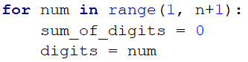

* To calculate the sum of digits of given number num, you might repeat the following: sum the last digit   
  (num % 10) and remove it (sum = sum / 10) until num reaches 0.

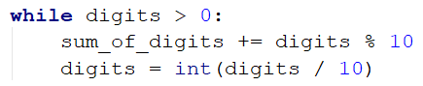

* Finally print the result :

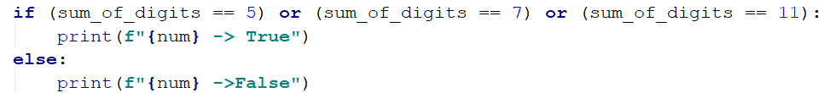

## Convert Meters to Kilometers

You will be given an integer that will be distance in meters. Write a program that converts meters to kilometers formatted to the second decimal point.

### Examples

|  |  |
| --- | --- |
| **Input** | **Output** |
| 1852 | 1.85 |
| 798 | 0.80 |

### Hints

* First we read the input number (which will be int)



* Then convert it to km



* And finally print the number to the second decimal point



## Pounds to Dollars

Write a program that converts British pounds to US dollars formatted to 3th decimal point.

1 British Pound = 1.31 Dollars

### Examples

|  |  |
| --- | --- |
| **Input** | **Output** |
| 80 | 104.800 |
| 39 | 51.090 |

### Hints

* Read the pounds (int)



* Convert them to dollars



* Print

